ORDER INFO FOR: COMPLETE THYMIC FORMULA & PARENT OILS

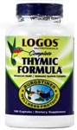

Complete Thymic Formula

Logos Nutritionals 1-800-556-5530 (speak w Jill)

**Although these products may be found on other sites such as Amazon, when it comes to supplements my policy is to purchase directly from the manufacturer.
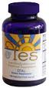
Parent Essential Oils

Yes Products 1-866-937-1124

Give them my ID # 73974733

*** (Do not order online ----- the price is higher online.)

Complete Thymic Formula

Logos Nutritionals 1-800-556-5530 (speak w Jill)

**Although these products may be found on other sites such as Amazon, when it comes to supplements my policy is to purchase directly from the manufacturer.

